NETWORK FOR JUSTICE
KANO OFFICE.
NARRATIVE REPORT
ON COMMUNITY OUTREACH SENSITIZATION PROGRAM.

PREAMBLE:
In line with the Network for Justice planned program, to conduct Community Outreach to sensitize the general public, to eschew Pre, during and Post-Election Violence, promote free, fair and credible Elections, come 2019, sensitize the Public on the retrogressive Political culture of Vote Buying, as well as creating greater awareness, for all to join government in its crusade against Corruption before, in the states of Kano, Kaduna and Sok/oto, the Kano office of the Organization set up a committee to map out a strategy. The Program, designed to be conducted in two LGAs, in each of the three Senatorial Zones of each of the three participating States.
Late October 2018, at about time for the commencement of the program, Kano State found itself in a very unique and peculiar situation, unfavorable for full and smooth conduct of a sensitization outreach program, particularly on matters of Corruption. Videos showing serving Kano State Governor, HE Dr. Abdullahi Umar Ganduje, allegedly receiving kickbacks from contractors, went viral on social media. This charged and heightened tensions, with Civil Society and religious Organizations, threatening to hold mass protests against the Governor. The Police came out forcefully threatening to clampdown on any seen threatening the peace, by way of organizing or inciting others. To organize any anti-corruption sensitization exercise, around the period, was tantamount to inciting the public against the Governor. The organization was therefore left with no option, than to come up with a program that will be re-assuring to both the security, traditional and LGA Authorities. Consequently, letters were written, explaining the antecedents of the Network for Justice, its past roles in peace promotion and the objectives of the outreach program, to the Kano Police Commissioner, all Divisional Police Officers, LG Chairmen and District Heads of all selected LGAs. In fact the State Police Commissioner, directed the Network for Justice Organization officials meet his designated officers for a thorough briefing. It was after which permission was granted, to freely move around the state to conduct the program.

CONDUCT OF THE OUTREACH PROGRAM:
In an effort to ensure all critical stakeholders were carried along, deliberate effort was made to ensure inclusiveness in the targeted groups. Traditional, Community, religious leaders, Youth and Professional groups were accorded priority consideration. The details for the conduct are provided in tabulation below;
S/N | ZONE | LGA | VENUE | DATE | TIME
1 | Kano Central | Kura | Kura Town | 02/11/2018 | 10:00am
 |  | G/ Malam | G/Malam Town | 02/11/2018 | 12:00pm
2 | Kano South | Rano | Rano Town | 09/11/2018 | 10:00am
 |  | Bunkure | Bunkure Town | 09/11/2018 | 2:00pm
3 | Kano North | D/Tofa | Dawanau Town | 14/11/2018 | 10:00am
 |  | Bichi | Badume Town | 14/11/2018 | 12:00pm

KANO CENTRAL SENATORIAL ZONE
The two selected LGAs in Kano Central Senatorial Zone are
Kura LGA and
Garun Malam LGA
And scheduled date of Outreach was 02/11/2018
OUTCOMES OF THE PROGRAM
- KURA LOCAL GOVERNMENT AREA:
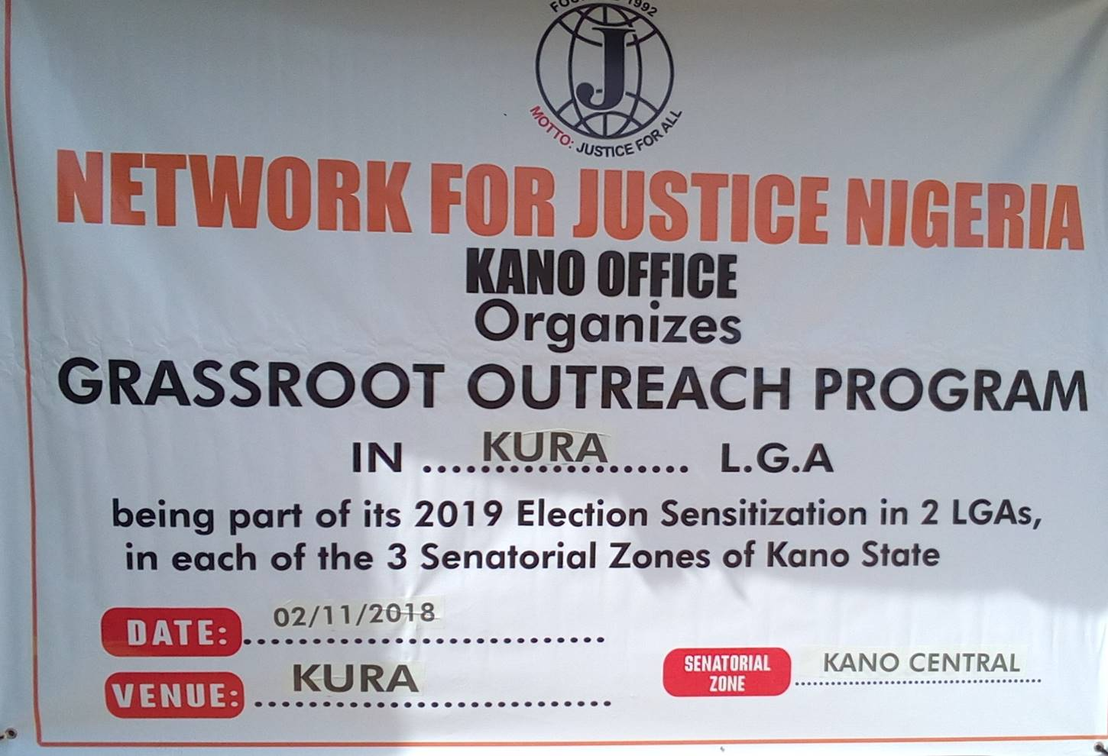
Kura Local Government was first to be visited. The District Head showed an exceptional enthusiasm on learning of the mission of Network for Justice. The N4J Team arrived Kura District Head Office at 9:32am and met with the waiting representatives of the District Council. The select audience comprised of Ward Heads, Community and Religious Leaders.
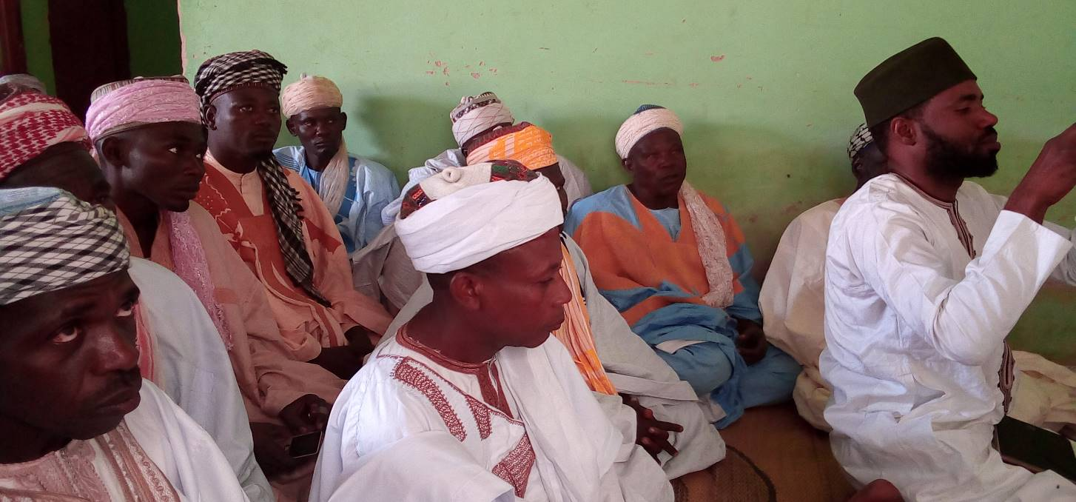
Upon arrival at the venue, already the audience were seated, the representatives of the District Head delivered his Opening, introduced the Network for Justice Team. The Team Leader, briefly outlined the history of the Organization, Objectives of the Program and proceeded with discussing the main issues of Credible, Free and Fair Election, Violence-free Election in 2019 and issues relating to Community participation in the Fight against Corruption.
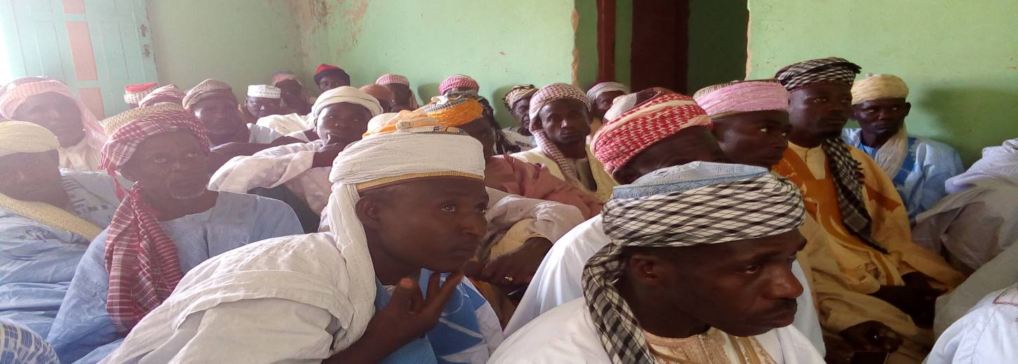At the end of the presentation, participants were invited to make own contributions, which were very rich and informative. Finally, representative of the District Head, the Chiroman Kura was invited to offer closing remarks, where he thanked and appreciated the Network for Justice for its efforts in single carry out such Public Awareness Campaigns. He also assured the team, their message would be passed down to the people at the smaller Wards and Villages, as their Ward Heads are part of the audience.
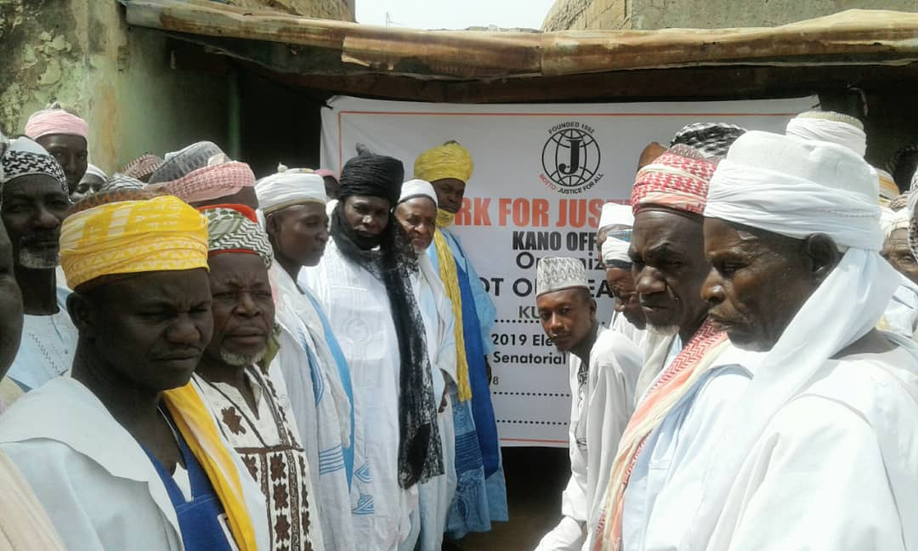

- GARUN MALAM LOCAL GOVERNMENT
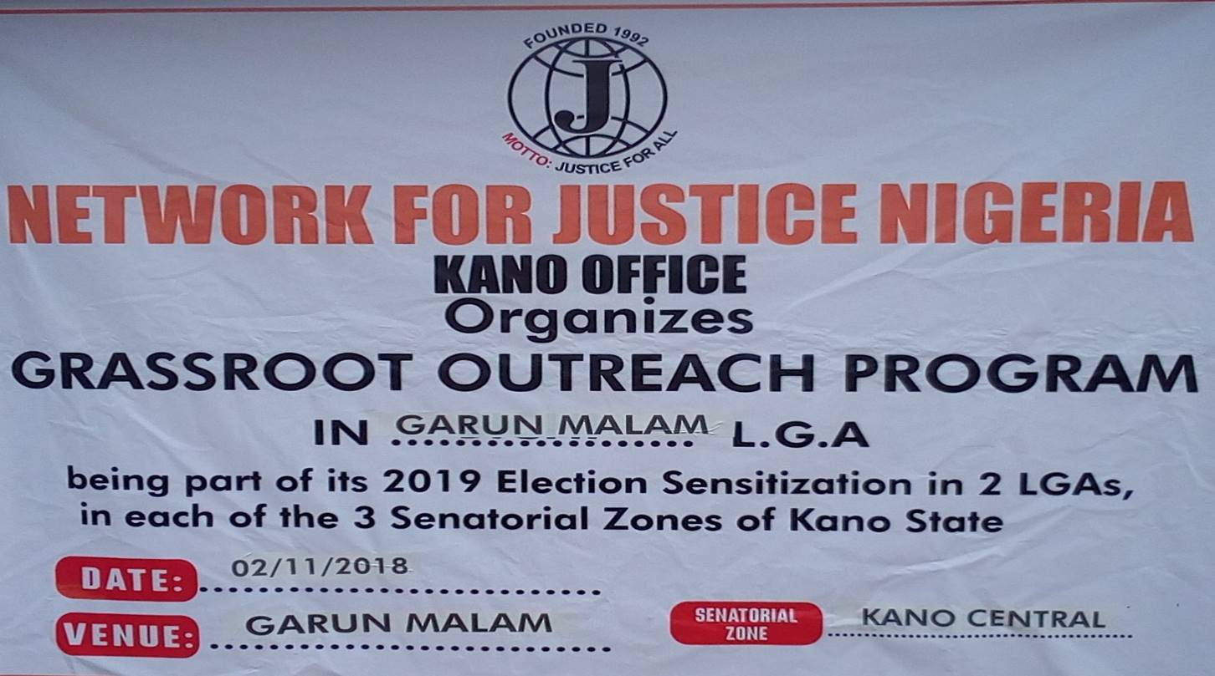
Garun Malam was the second selected Local Government in the Senatorial Zone to be visited. The Network for Justice Team arrived at about 11:51am. After formal homage to the District Head the team proceeded to the Town Square to meet with a waiting audience, made up of Representatives of Youth Associations, local Politicians, representatives of Traders and Farmers Associations.
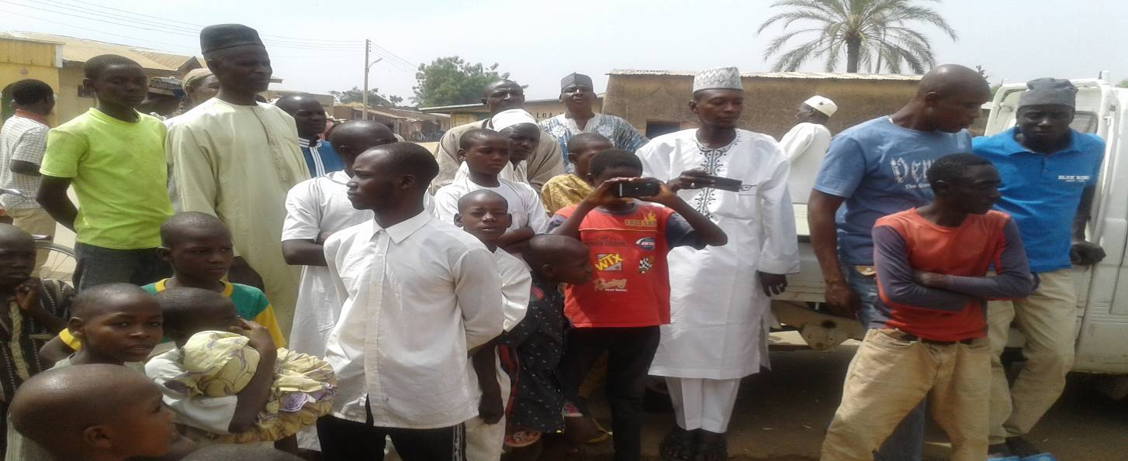
The team delivered the message by pointing out the benefits of ensuring credible, free and fair election as well as stressing the negative consequences of violence during and after elections, and the need to be more vigilant fight corruption. They were also urged to ensure a peaceful and harmonious co-existence in all the election processes.
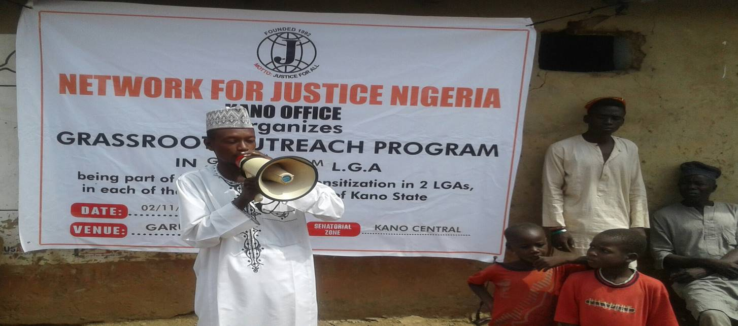
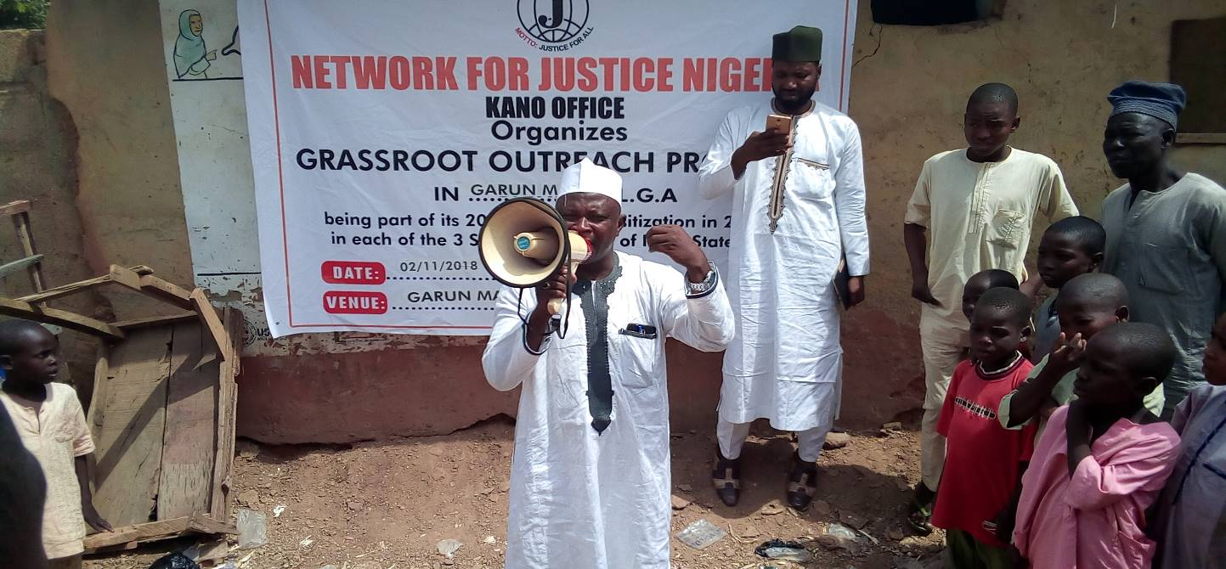
After thorough deliberation and analysis by the Network for Justice Team on these 3 key issues: Credible, free and fair Election, Violent free Election and Fighting Corruption, representatives of the various groups and Associations were invited to add their voices. All, with no exception expressed joy and gratitude, for the Outreach, and reaffirmed their commitment to the success and peaceful Election conduct in 2019.
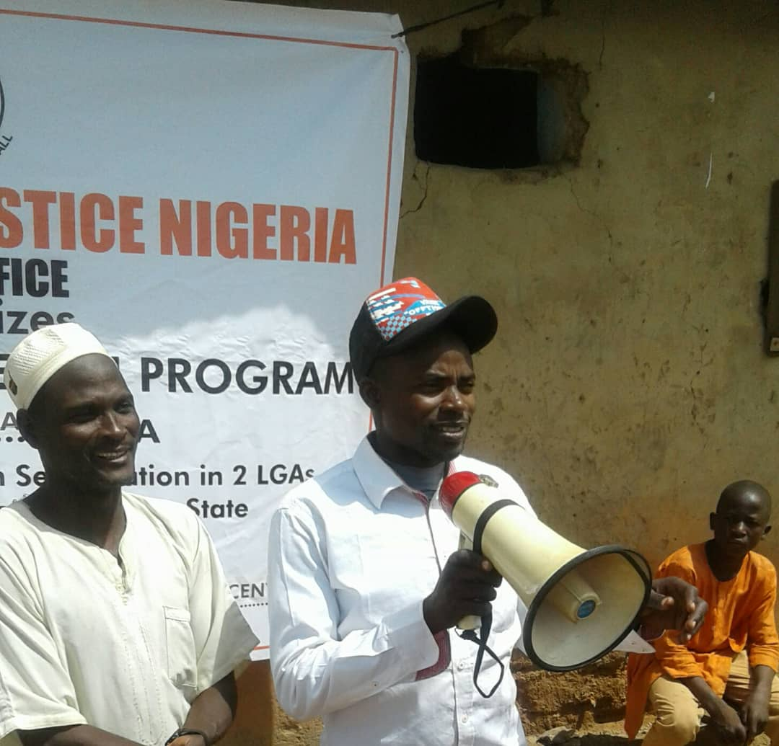
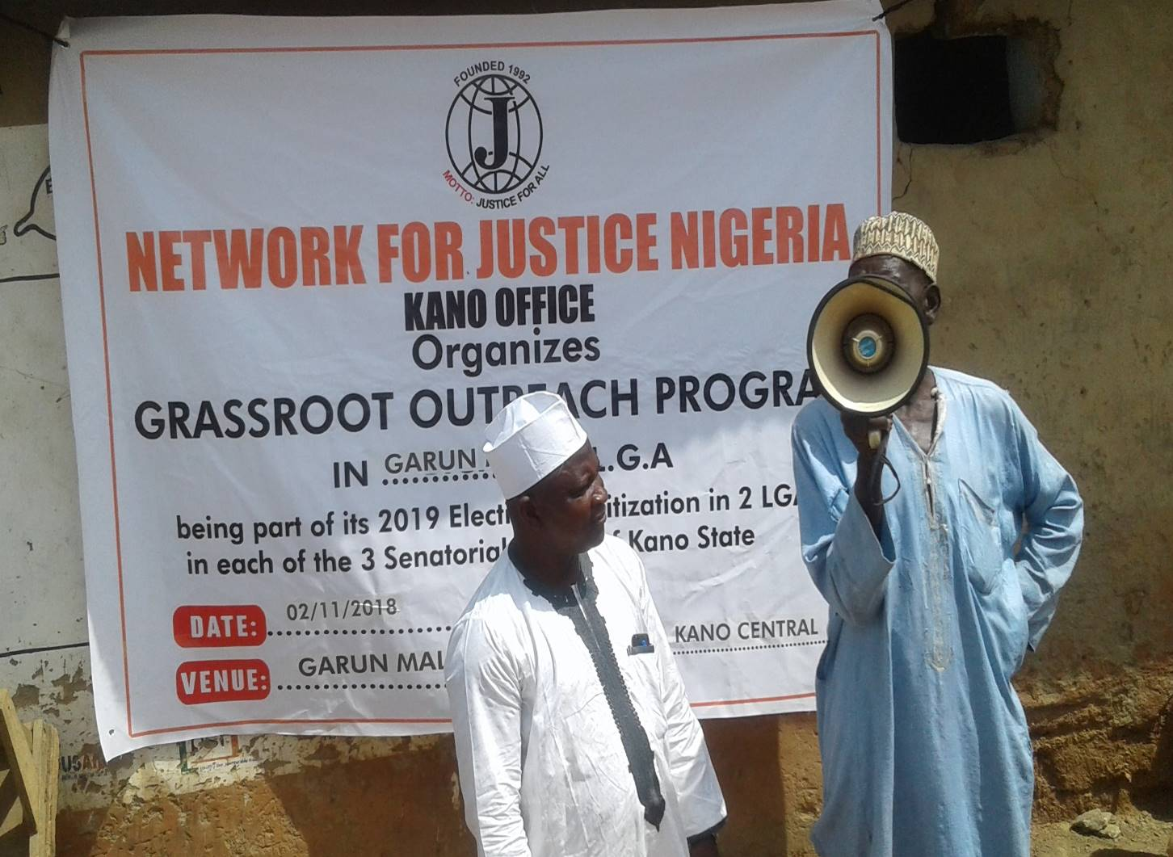

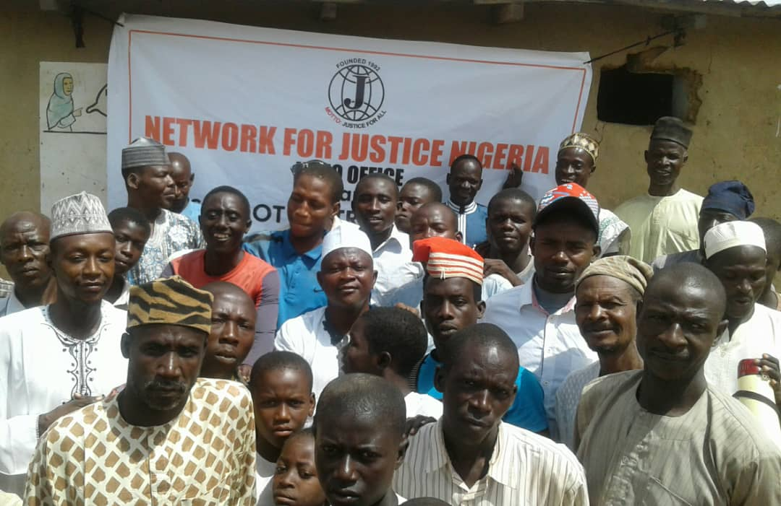
KANO SOUTH SENATORIAL ZONE
The two selected LGAs in Kano Central Senatorial Zone are
Rano LGA and
Bunkure LGA
Scheduled date of Outreach was 09/11/2018.
- RANO LOCAL GOVERNMENT:
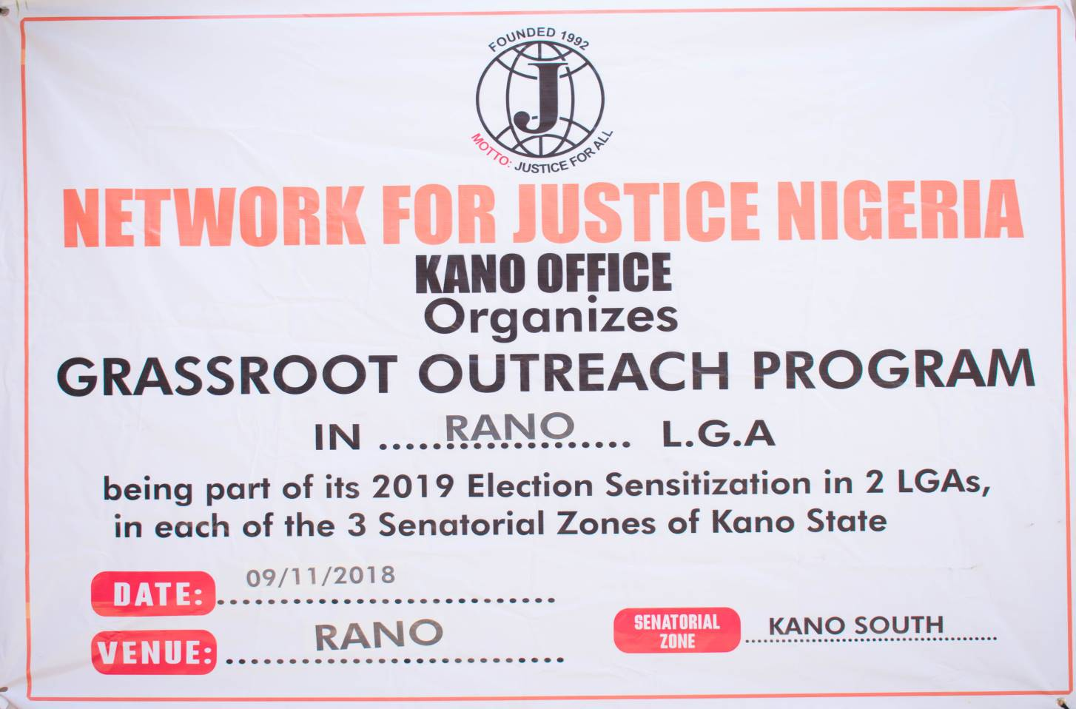
Rano Local Government was the first selected local government in Kano South Senatorial district to be visited by the Network for justice team. The team arrived Rano Town, at exactly 9.30am and headed straight to the District Heads Palace, to pay homage and commence engagement. The team met an enthusiastic waiting audience, made up of representatives of diverse groups, which included District and Ward Heads, Youth and Religious leaders.
Upon arrival, the team met all of them ready and seated.
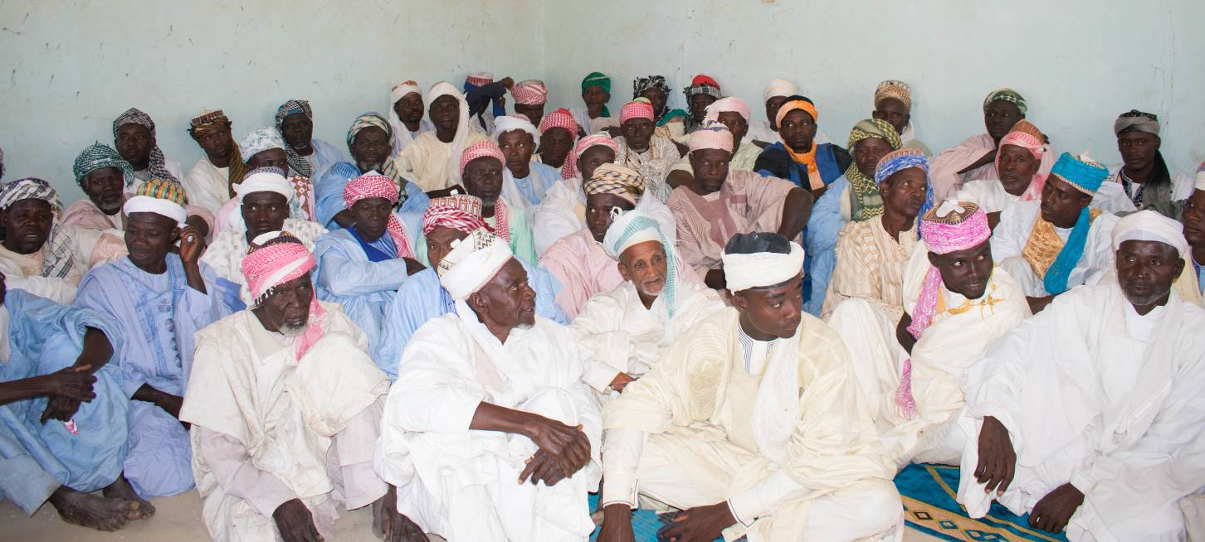
The Secretary of the District Council, who was also the representative of the District Head gave the Welcome address and went further to introduce the Network for Justice Team and the importance of their visit. He emphasized the deliberate objective of selecting them, being representatives of diverse Societal groups, being community and group Heads and leaders of the people, the message will much more conveniently trickle down to their people at their villages peer group meetings and Communities.
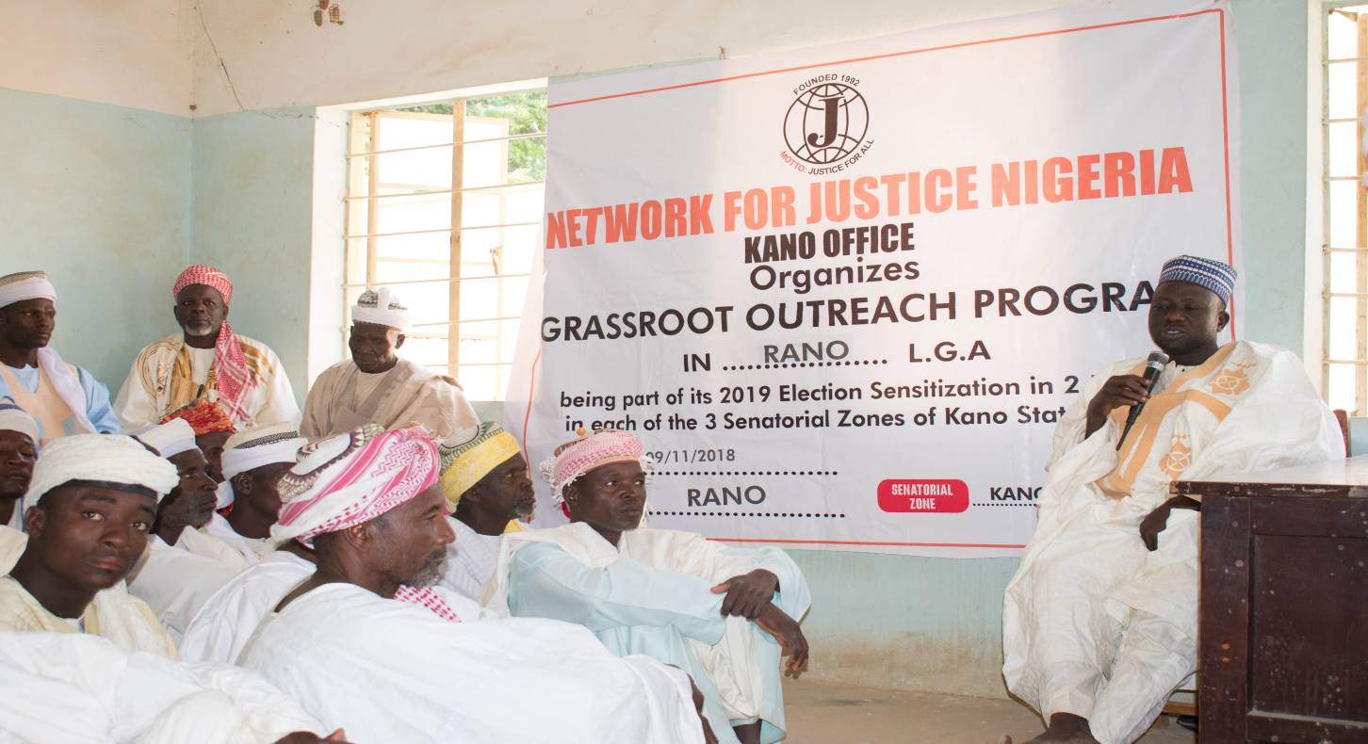

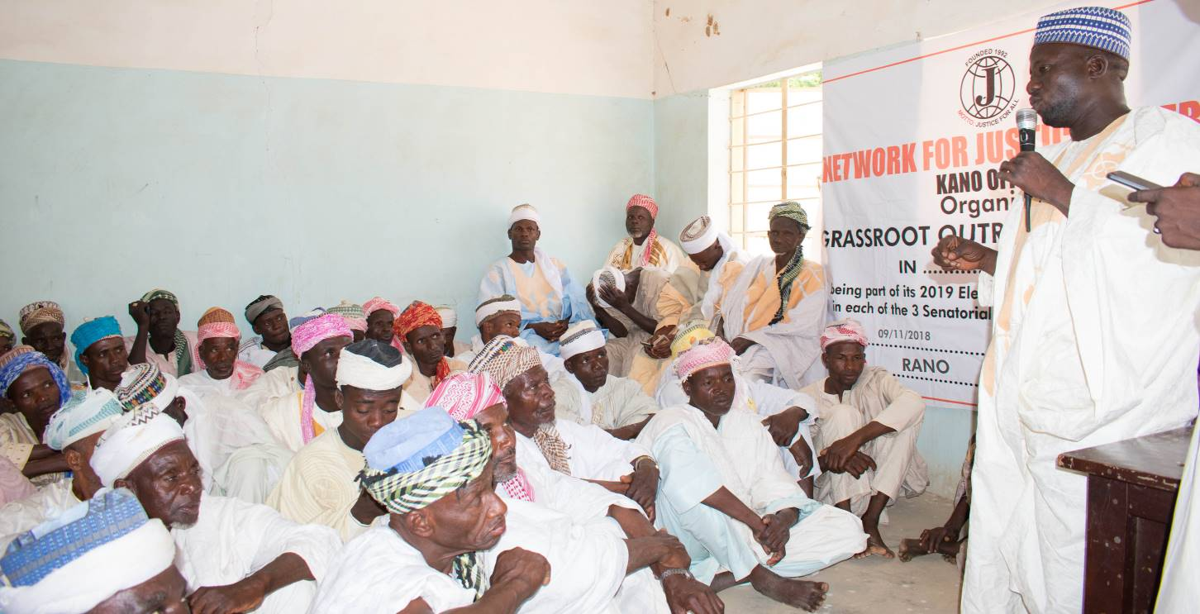
The team leader briefly outlined the history of the Network for Justice, as an Organization and its being a non-political, religious or ethnic organization. He stated the objectives, mission and importance of the outreach which is to sensitize the people to help ensure Credible, free and fair elections. To also partake in helping ensure non-violence during and after Elections, and finally to sensitize them to preach the message of on-going fight against Corruption, at all strata of our in our Communities, particularly in helping monitor those in authority.
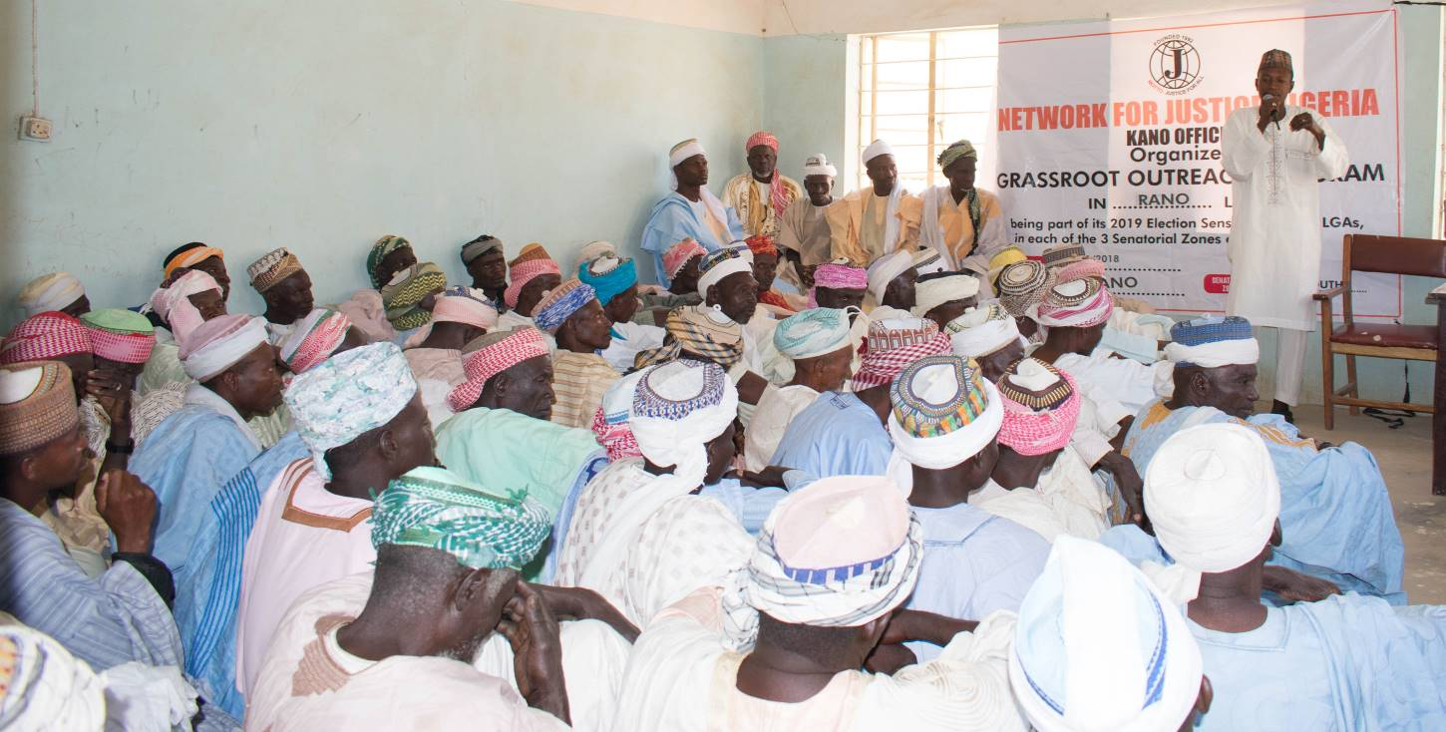
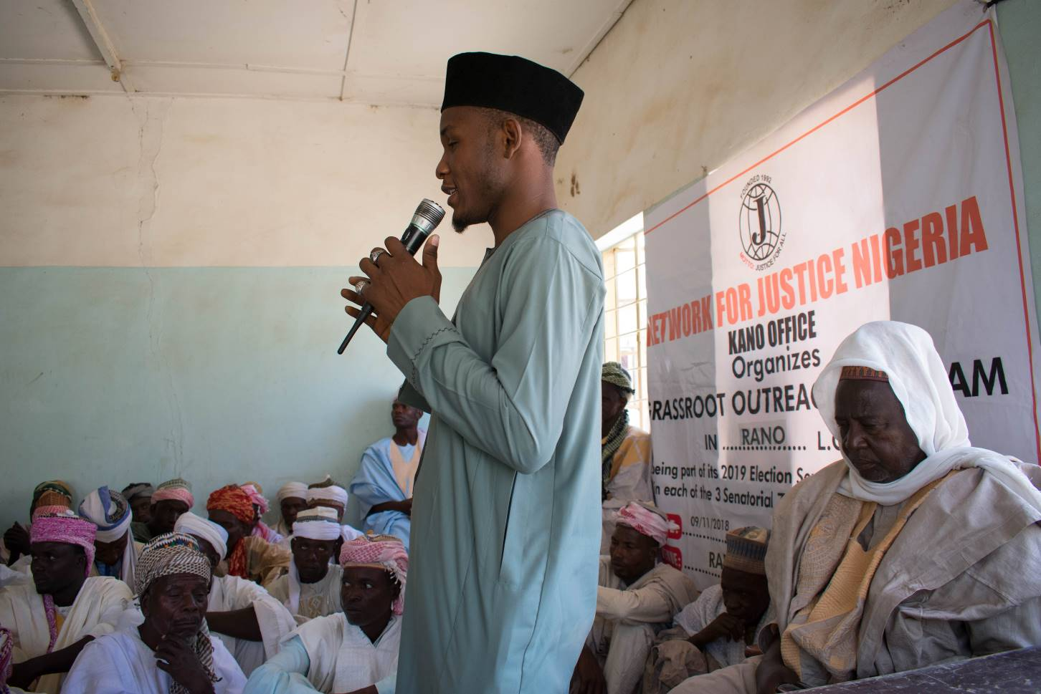
At the end of the discussions, some Community and Youth group leaders were invited to make contribution, which were very rich and informative.
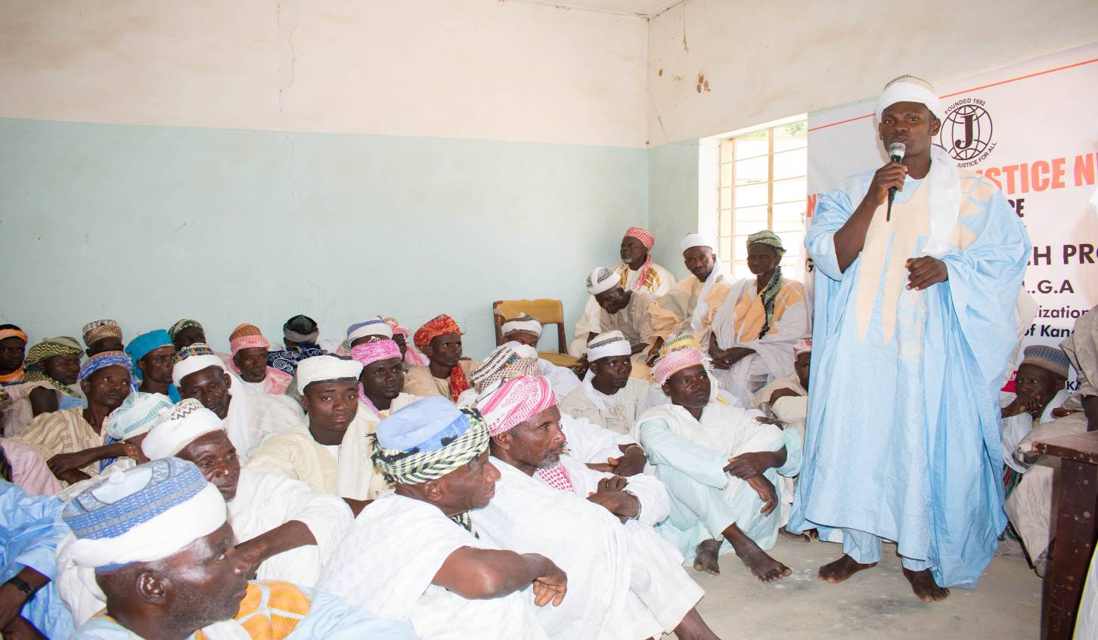
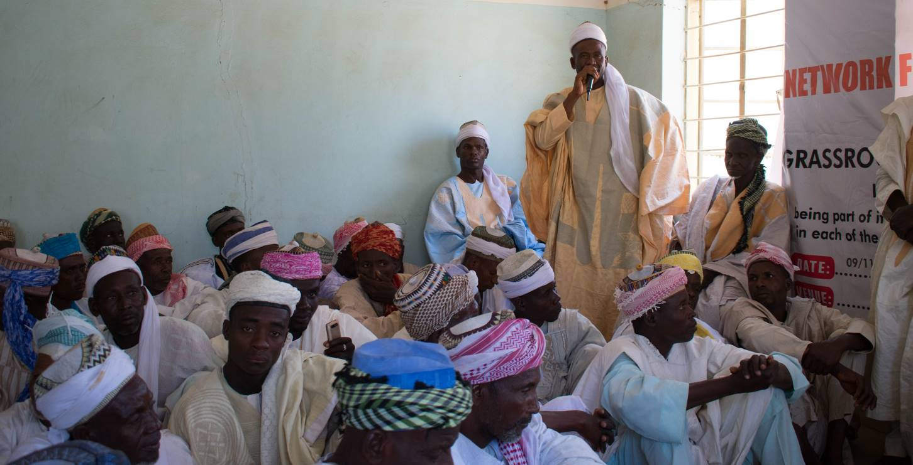
Finally, the Chief Imam of the District was invited to offer closing remark, where he thanked and appreciated the Network for Justice Team for its efforts in carrying such important public awareness. He prayed for a successful, Violence free Election and also assured the team their message will be passed down to the people through group engagements, Juma’at Sermons and regular prayer sessions. He also assured the team rest participants will also ensure passage of the message at smaller wards and village levels. Refreshments were then served to participants, ending with a group photograph of the advocacy team and some select participants.
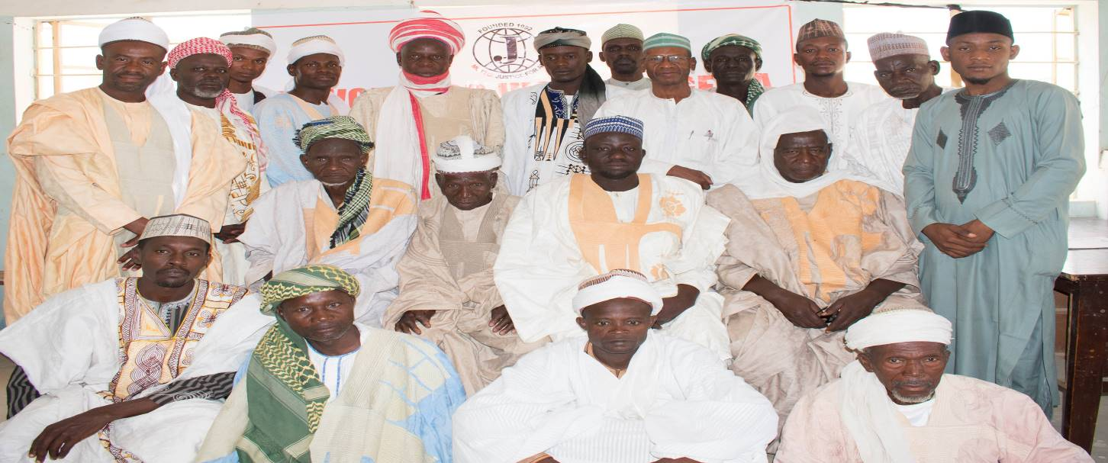
- BUNKURE LOCAL GOVERNMENT:
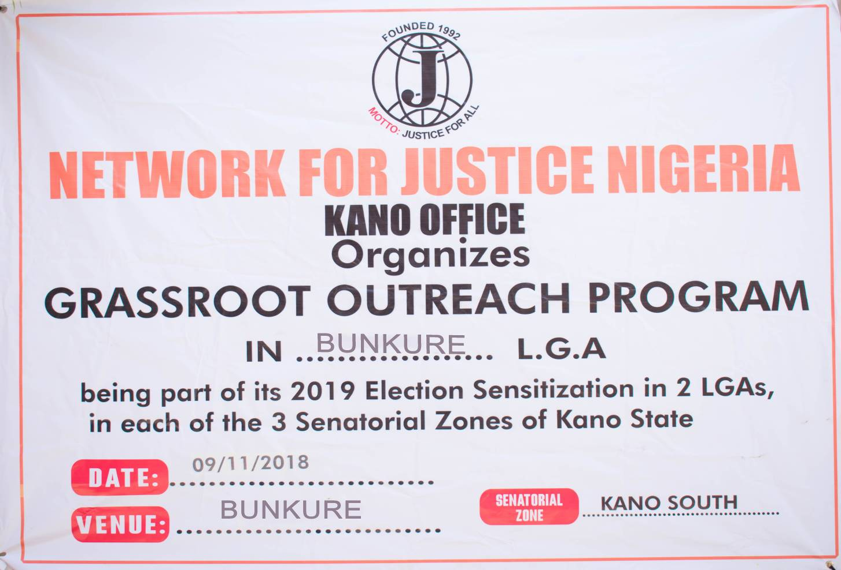
Bunkure Local Government was next in the Kano South Senatorial to be visited by the Network for justice Advocacy Team. The team arrived Bunkure Town at 12.30pm and proceeded straight to the District Heads residence, the team was welcomed with a very hospitable reception. The team was led to pay homage to the District Head, who introduced the team to his Palace functionaries. The District Head, the Barayan Kano, engaged the team a very lengthy, but educative and fruitful conversation on Corruption, Election violence during and after election, and the new phenomenon of vote buying, particularly in very remote Communities. The team had a group Photograph with the District Head and proceeded to the Bunkure City Central Mosque, for the Friday Community congregession prayers.
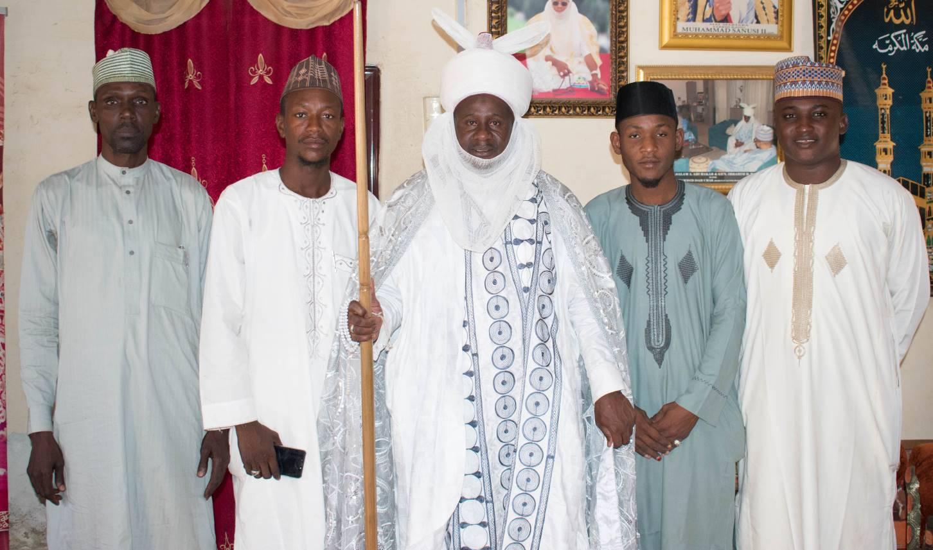
Interestingly, the District Head had already directed the Chief Imam to center the core of his Juma’at Sermon to dwell primarily on Corruption, lection Violence and the importance of Peace promotion in the Community.
Immediately the Juma’at prayer was concluded, the District Head directed everybody to remain seated for an important message to be delivered. The Advocacy Team, was granted a rare privilege of being invited into the mosque premises to directly address the mammoth crowd of the congregession, thousands. After routine introduction of the Network for Justice and what it stands for, the team proceeded to highlight pointed the benefits of having a credible, free and fair Election, stressing out the negative consequences of violence during and after Elections. It also hammered on the cancerous effects of corruption and why it becomes necessary for all and sundry to join in the fight against Corruption.
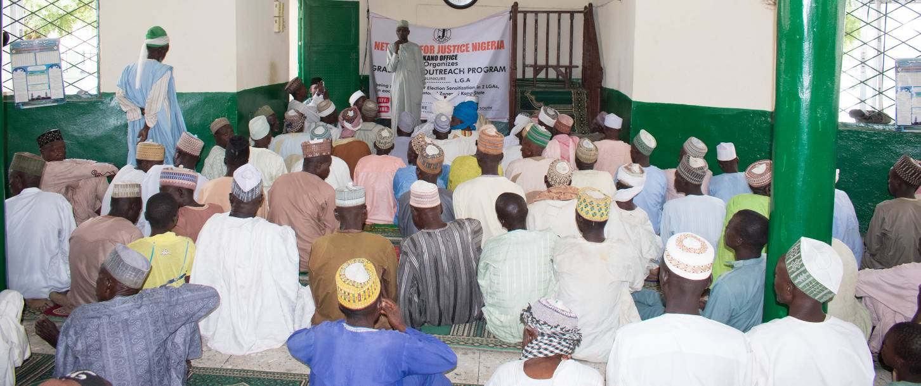
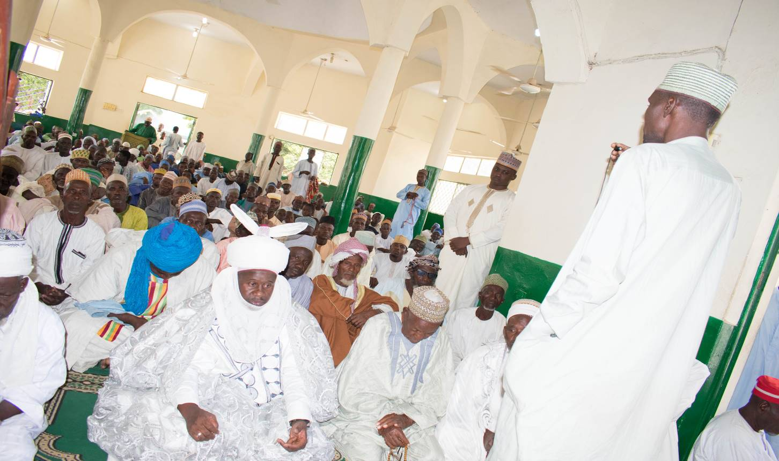
They were also urged to actively engage in peace promotion and ensure peaceful and homogenous coexistence before, during and after all the Election process. After a long deliberation by the team, the District Head directed the Chief Imam to also compliment the remarks made by the advocacy team. He also re-emphasized on the benefits and advantage of peaceful co-existence, as enshrined in the relevant Muslim scriptures and pray for a peaceful election process.
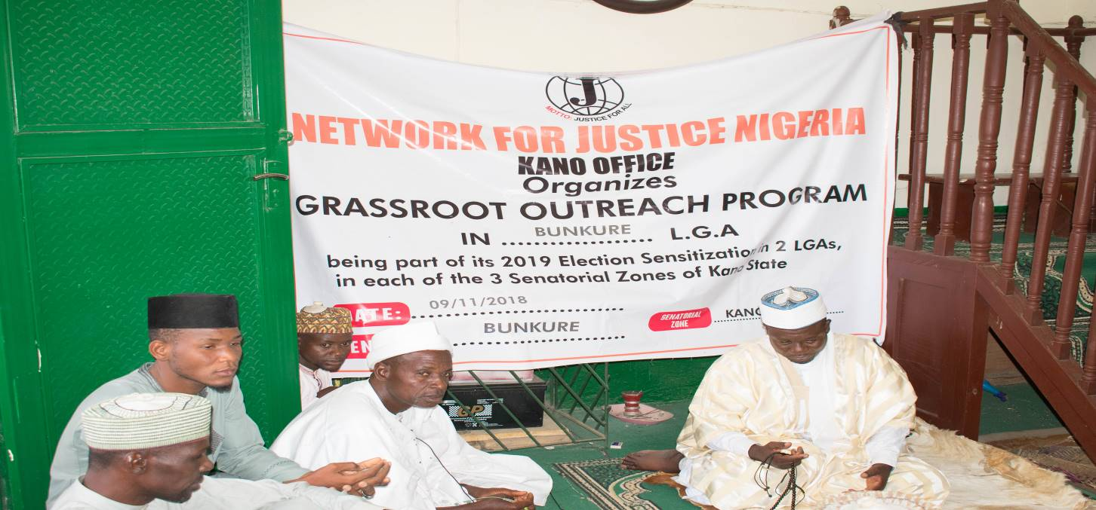

The District Head expressed his joy and appreciation for the outreach and re-affirmed their commitment to the success and peaceful Election conduct in 2019. Special prayers were offered, refreshments served outside the Mosque premises, and the engagement rounded up with a group photograph of the team, District Head and select Community chieftains.
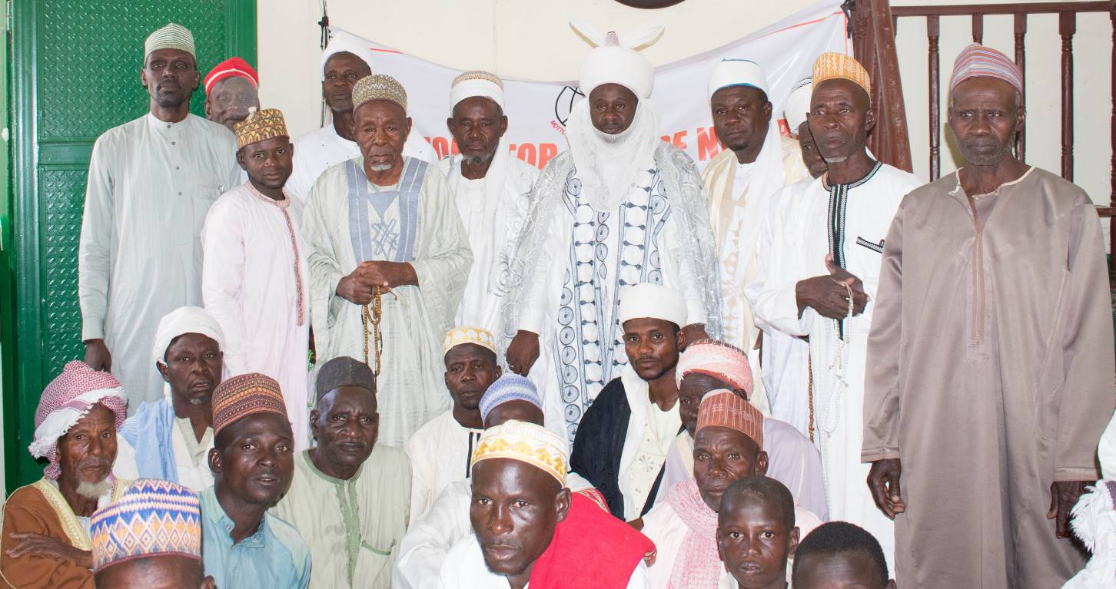

KANO SOUTH SENATORIAL ZONE
The two selected LGAs in Kano Central Senatorial Zone are
Dawakin Tofa LGA and
Bichi LGA
Scheduled date of Outreach was 09/11/2018
- DAWAKIN TOFA LGA
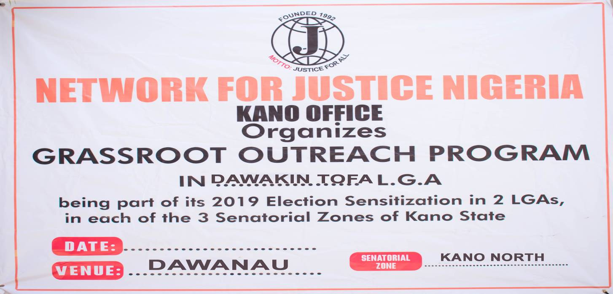
Dawakin Tofa LGA was the first LG to be visited in Kano North Senatorial Area. The Dawanau Market was selected in view of its National and International significance. It is arguably one of the biggest grains market in Nigeria, daily besieged by people, not only from across Nigeria, but other West and Central African Countries of Niger, Mali, Togo, Chad, Cameroon and Ghana. It is also home to people from diverse ethnic and religious backgrounds. Having sufficiently interacted with traditional and religious leaders from other Senatorial Zone, it was thought taking the Advocacy directly to the people, particularly with history of ethnic and religious disharmony, will be in tendon with the project objective. Similarly, been a heartthrob of huge Economic engagements, it was considered a good ground to enlighten, to mass audience, the message of the fight against Corruption.
The Advocacy Team arrived Dawanau Market, the famous International Grains market, in Dawakin Tofa LGA, of Kano State at about 1.30pm. Dawanau Market is a melting point of over 10,000 shops, a Center of International Business for over 50,000 people from different sections of Nigeria, other West and Central African Countries.
Before appointed date of engagement, the advocacy team had to specially visit the Dawanau Market Management Committee, to acquaint them with the objective of the Program. They welcome and expressed enthusiasm for the visit, advising that the tradition in the market, is to assemble the Market Assembly, consisting of different trade unions, ethnic, religious and farmers associations, with represent diverse interests of different interest groups operating in the Market.
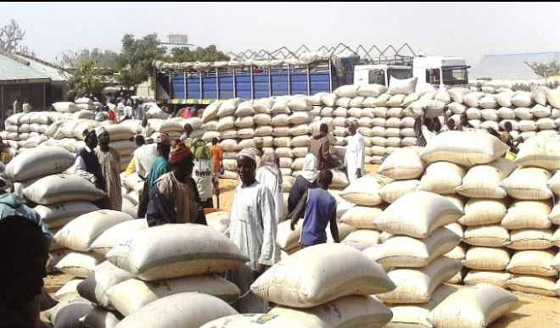
Upon arrival, the team along with the leadership proceeded to the market square which serves at the venue of the meeting, to meet an enthusiastic waiting audience, made up of representatives of diverse groups and associations, including leaders of Laborers Associations, Grain Marketers Groups, Truck Drivers Association and a number of customer’s representatives.
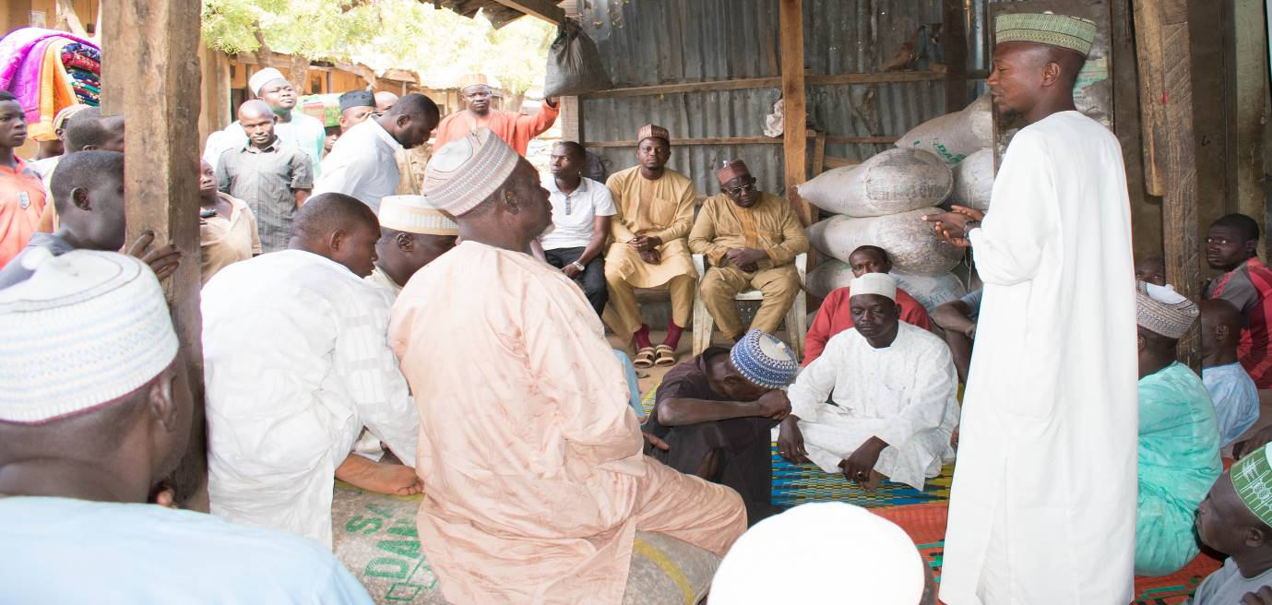
The Chairman of the Market Management Committee gave the welcome address and proceeded to introduce the Network for Justice Advocacy Team and the objective of their visit. He emphasized the significance of selecting the market being an International Centre of Commercial activities, the message will much more conveniently trickle down to thousands of the market group members, their families and Communities.
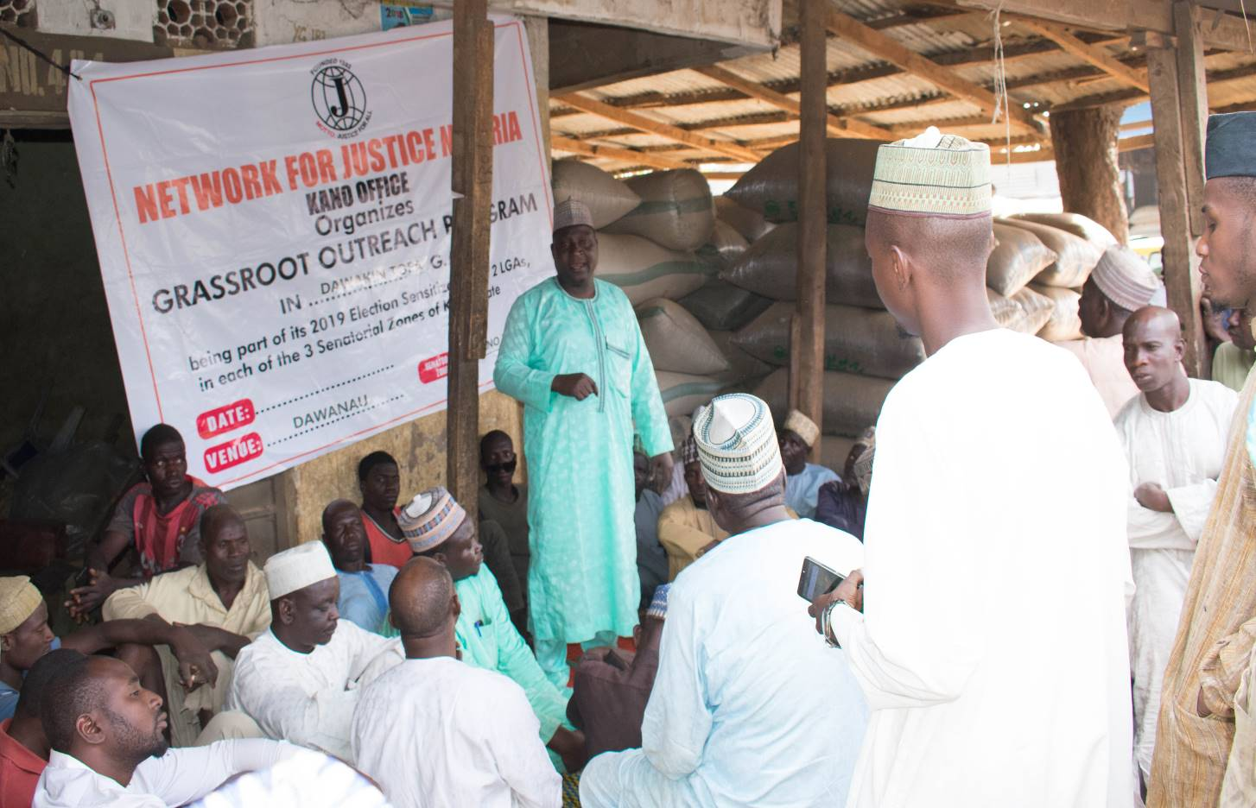
The team leader started by briefly outlining the history of the Network for Justice, as an Organization, its being a non-political, religious or ethnic organization, as well as its contribution in Peace promotion and the fight Against Corruption. He stated the objective, mission and importance of the outreach which is to sensitize the people to help ensure Credible, Free and Fair elections, to also partake in helping to ensure Nolo0on-violence during and after election and finally to sensitize them to preach the message of on-going fight against Corruption, at all strata of our communities, particularly in helping, monitor authorities.
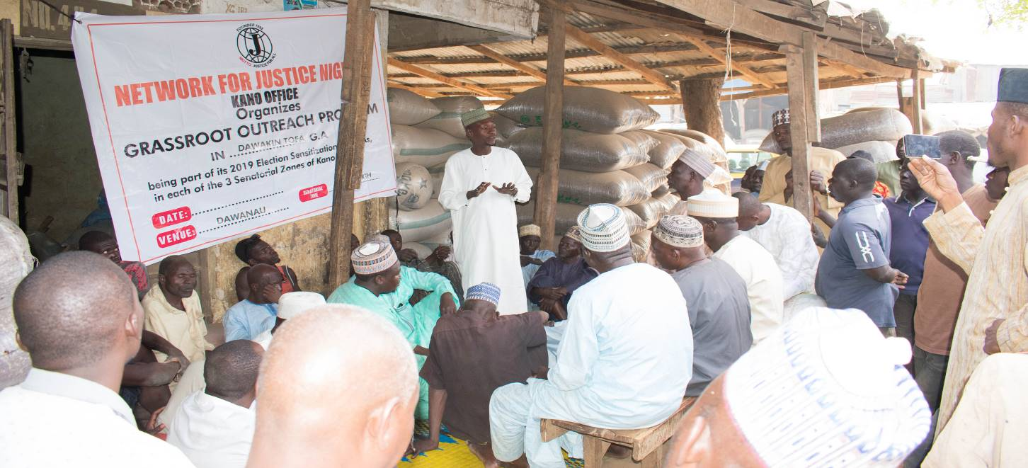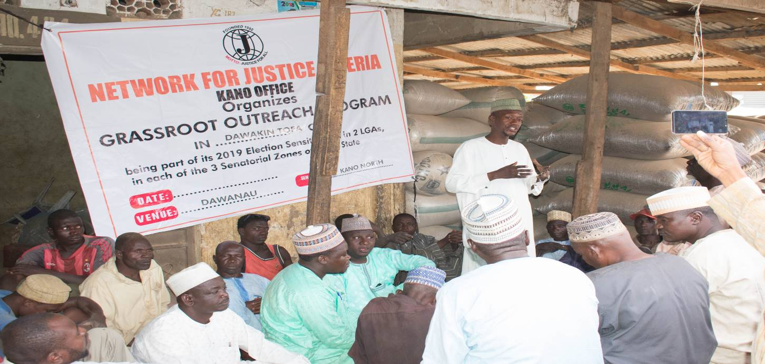
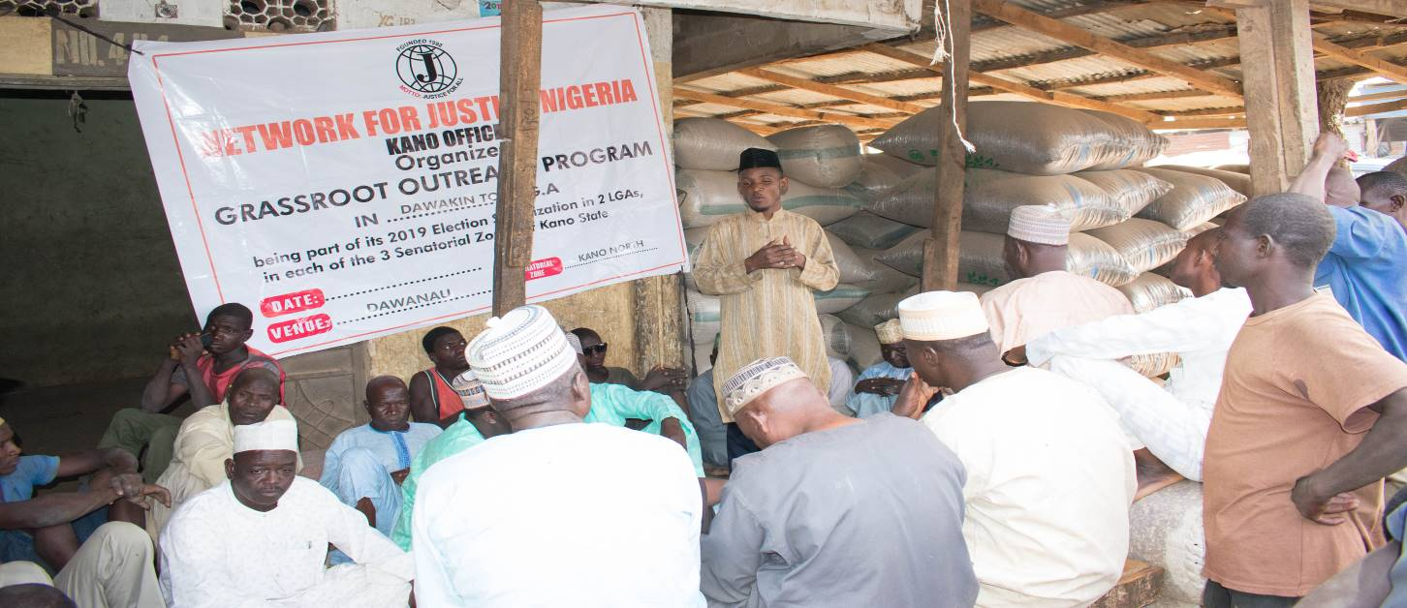
At the end of the discussion, leaders of different groups and associations were invited to make contributions which were very rich and informative.
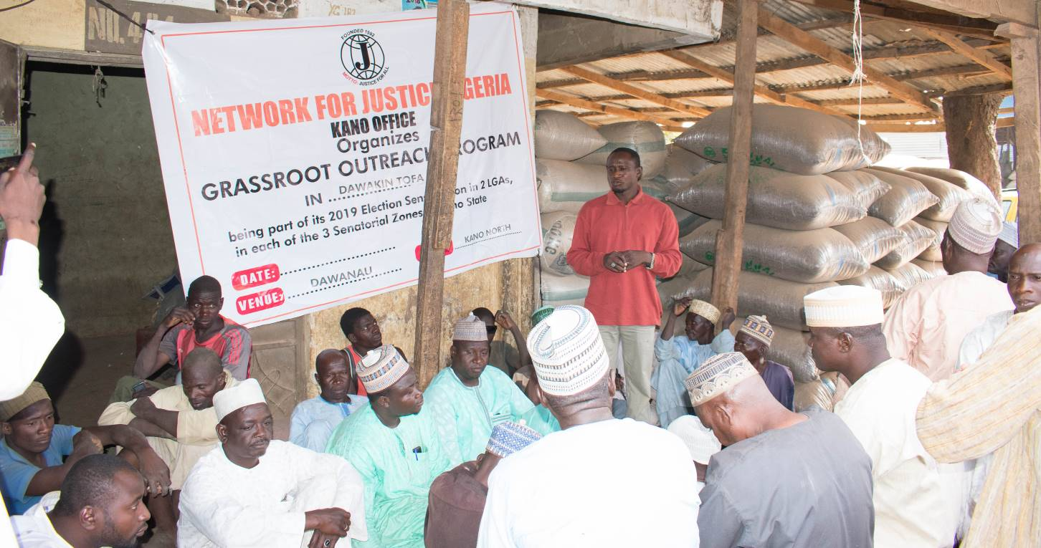
Finally, the Secretary of the market association was invited to give a closing remark, where he thanked and appreciated the Network for Justice Team for its effort in carrying such important public awareness and look forward to more engagements targeted at collective societal development. He assured the team their message will be passed down to different groups members, families and Communities.
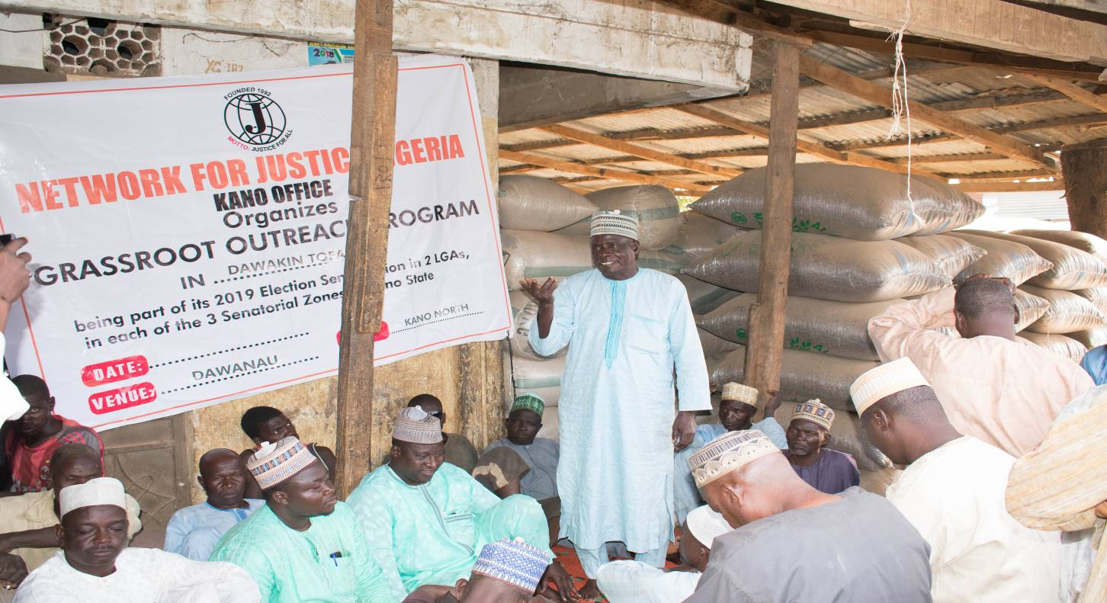
The meeting ended with some refreshments and a group photograph of the team and some selected group and Association leaders.
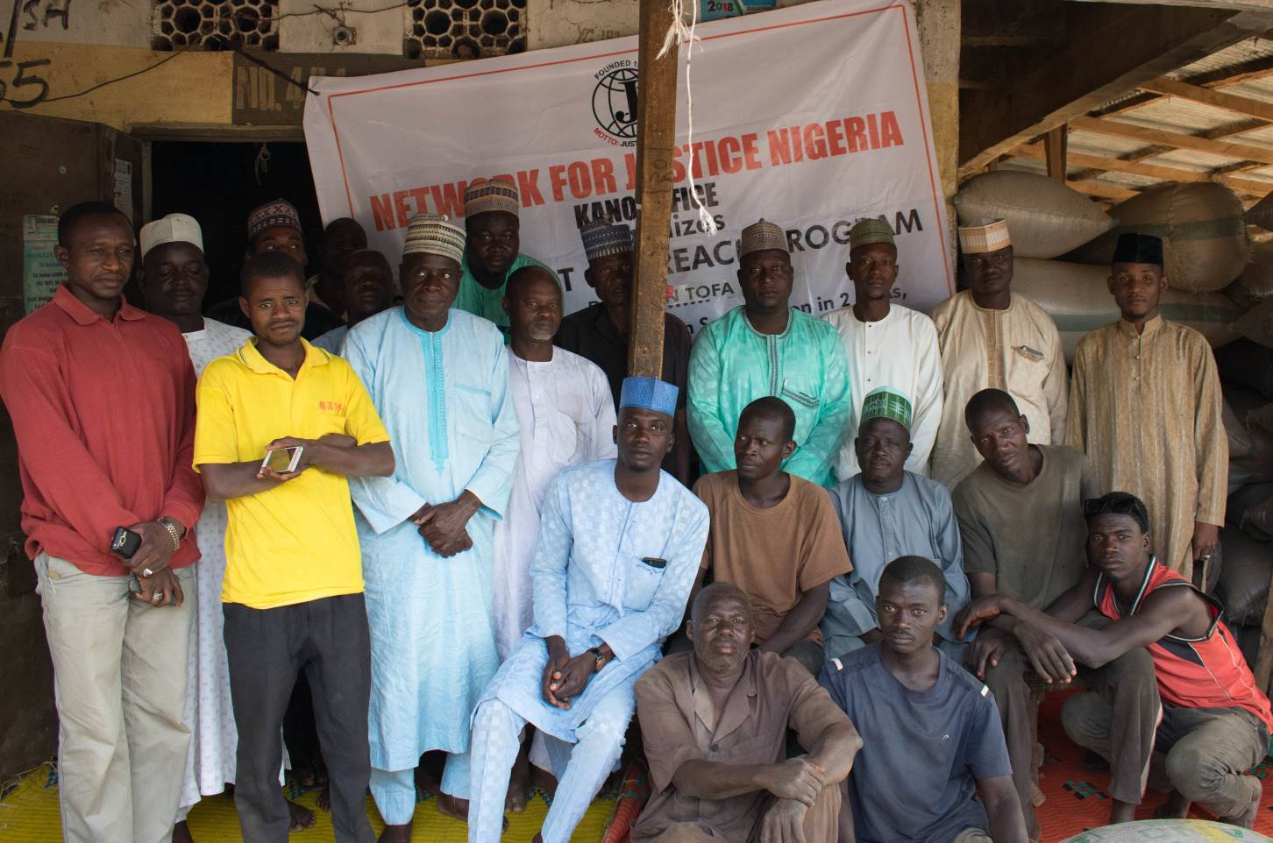

2. BICHI LOCAL GOVERNMENT
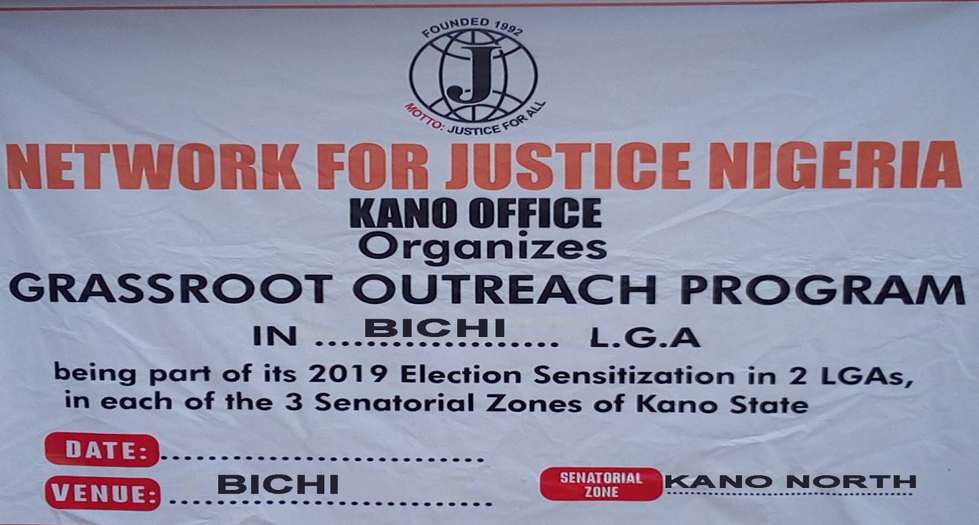
Bichi Local Government was the second selected local government in Kano North Senatorial district to be visited by the team, which arrived Bichi Town, at exactly 11.30am, heading straight to the District Heads Palace, to pay homage and commence engagement. He was unfortunately unavailable, due to official engagements. The team proceeded to the District Council chambers, to meet an enthusiastic waiting audience, comprising of representatives of select stakeholder groups, which included Chieftains of District Council, Ward Heads, Youth and Religious leaders.
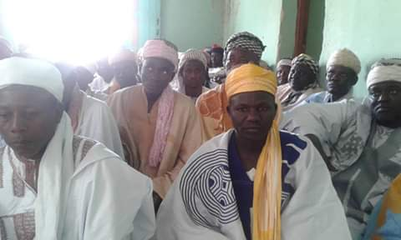
The Secretary to the District Council, who also sat in for the District Head, gave the Welcome address, went further to introduce the Network for Justice Team and the objective of their visit. He emphasized the deliberate objective of selecting them, being representatives of diverse Societal groups. Being Community and Group Heads and leaders of their people, he argued, the message will much more conveniently trickle down to their people at their respective villages, Peer group and Community meetings.
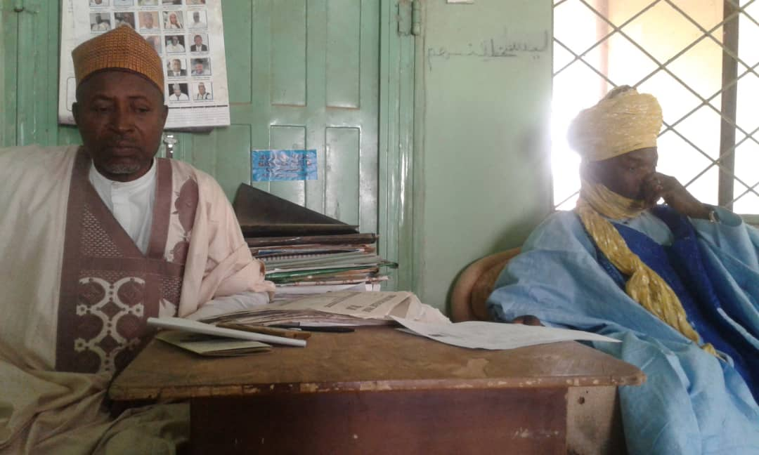
The team leader, Abdullahi Yusuf Ahmed briefly outlined the history of the Network for Justice, its history of being a non-political, religious or ethnic organization. He stated the objectives, mission and significance of the outreach, which is to sensitize the people to get fully involved the fight against Corruption, actively participating in ensuring Credible, free and fair elections, ensuring non-violence during and after Elections, and finally sensitizing other to shun the retrogressive culture of vote buying, at all strata of their Communities. Participants were then invited to contribute and where necessary seek additional clarification.

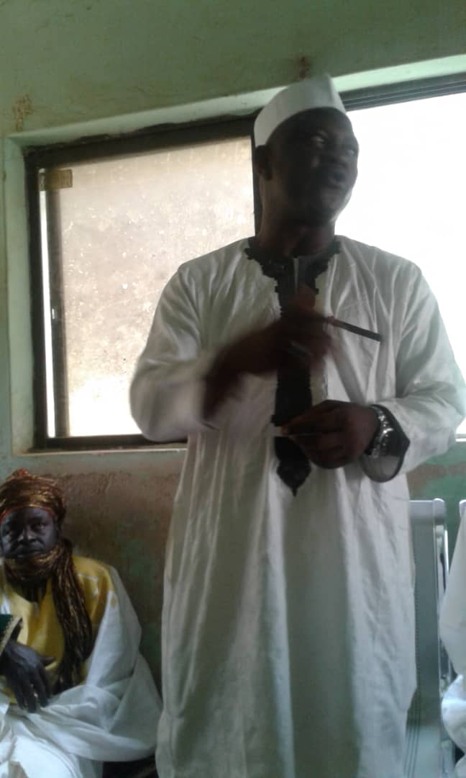
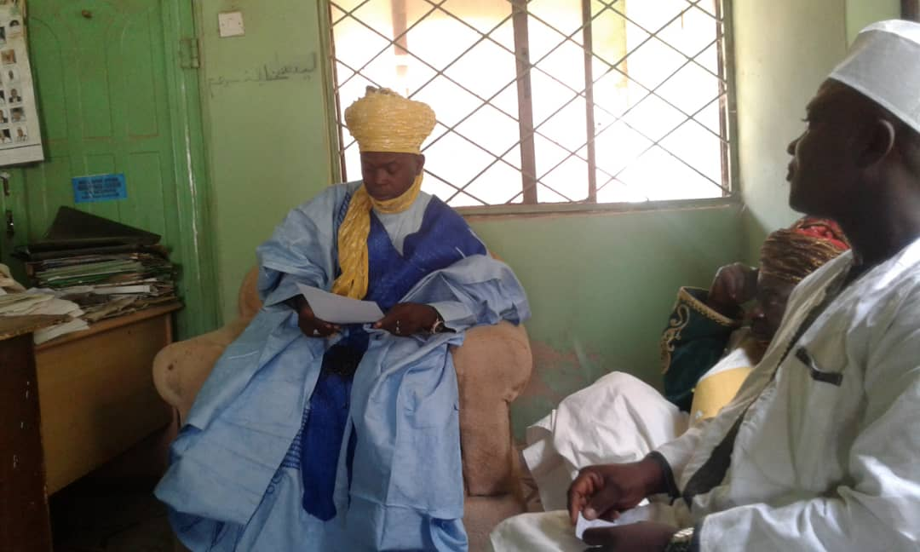
Finally, the Chief Imam of the District was invited to offer closing remark, where he thanked and appreciated the Network for Justice Team for the efforts in carrying out such important public awareness exercise. He prayed for a successful, Violence free Election, assuring the team their message will be passed down to the people through Social engagements, Juma’at Sermons and regular prayer sessions. He also assured the team, rest participants will also ensure passage of the message at smaller wards and village levels. Refreshments were then served to participants.

OBSERVATIONS:
- Local Communities, particularly in Northern part of Nigeria are in dire need of a sustained Sensitization Campaign, to adequately sensitize them on their Civic duties and responsibilities. The campaign against Vote Buying and Corruption, will not succeed, without their direct involvement and participation. They need to realize, it is only through their close monitoring, public officials will see the necessity to be accountable in their stewardship.
- Public institutions, particularly the Police Command, The EFCC, and ICPC, need to extend their operations to the lowest strata of the society. A people oblivious of their functions and mode of operations, will hardly be of any operational value. And for them to succeed effectively, they need the involvement of the citizenry.
- CSOs need to be adequately supported, to collaborate and compliment government efforts in providing services.
- Traditional institutions, including Religious and Community rulers, remain an effective and indispensable structure in rural community mobilization.

ADVOCACY TEAM:
- Bala Abdullahi Gaduwama - Team Leader/Monitoring
- Maigari Garba Indabawa - Monitoring
- Auwalu Saleh Tudun Murtala - Advocacy
- Abdullahi Yusuf Ahmad - Advocacy
- Usman Ishaq Adam - Advocacy
- Yakubu Muhammad - Logistics
- Haidar Ali Abdullahi - Media/ICT

CONCLUSION:
The sensitization outreach, has been a good eye opener, not only for the participants from across the selected LGAs, but even to the Network for Justice Advocacy team. It has afforded them first hand opportunity, to interact more closely with the grassroots communities, at different societal strata, and learnt a lot, on their perception of governance, and their role in the democratic process. We commend and appreciate the coordinating leadership of the organization, for availing it the opportunity to mobilize the grassroots strata of our communities, towards enhancing overall wellbeing.

Malam Bala Abdullah Gaduwama
Kano Office Project Coordinator.

